Lab # 1
Activation Functions

OBJECTIVE

- To understand and implement various activation functions used in artificial neural networks and analyze their impact on neural network training.

THEORY
Each neuron has an activation function that performs computation. Different layers can have different activation functions but neurons belonging to one layer have the same activation function. In DNN, a weighted sum of input is calculated based on weights and inputs provided. Then, the activation function comes into the picture that works on weighted sum and converts it into output.
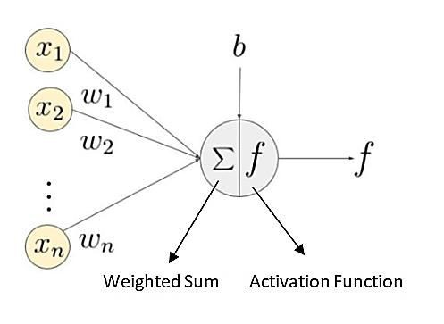
It helps in making the decision about which information should fire forward and which not by making decisions at the end of any network. In broadly, there are both linear as well as non-linear activation functions, both performing linear and non-linear transformations but non-linear activation functions are a lot helpful and therefore widely used in neural networks as well as deep learning networks.
Common activation functions include:

- Linear activation function
- Sigmoid
- Tanh (Hyperbolic Tangent)
- ReLU (Rectified Linear Unit)
- Leaky ReLU

Students will implement these functions, visualize their behavior, and understand their applications in neural networks.

Minimum Theoretical Background:

Linear Activation Function:
Linear Activation Function: The linear activation function, also known as "no activation," or "identity function" (multiplied x1.0), is where the activation is proportional to the input. The function doesn't do anything to the weighted sum of the input, it simply spits out the value it was given.
Dr. Abhishek D. Patange, Mechanical Engineering, College of Engineering Pune (COEP)
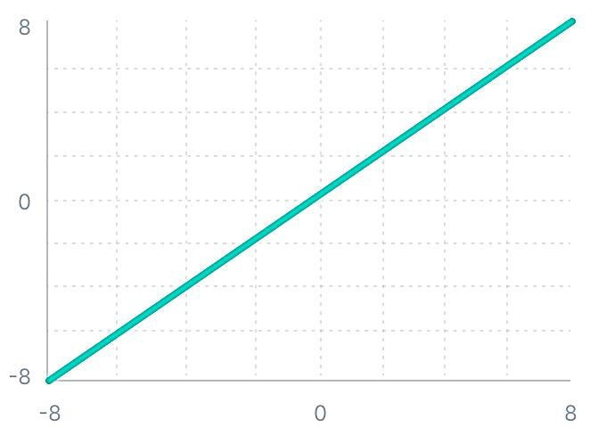

Linear Activation Function
Mathematically it can be represented as:
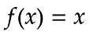
However, a linear activation function has two major problems :
- It’s not possible to use backpropagation as the derivative of the function is a constant and has no relation to the input x.
- All layers of the neural network will collapse into one if a linear activation function is used. No matter the number of layers in the neural network, the last layer will still be a linear function of the first layer. So, essentially, a linear activation function turns the neural network into just one layer.

Sigmoid Activation Function:
This is also known as Logistic function. The graphical representation is provided in figure. Equation gives the output values for this function.
F(x) = [ 1/(1+ e -ax)]

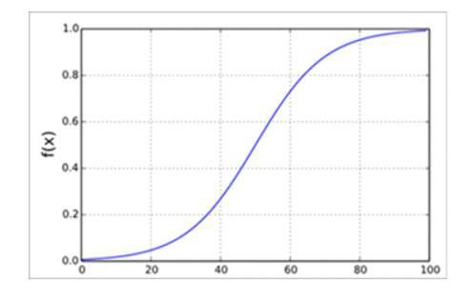
Figure: Binary sigmoidal function

Squeezes the input into a range between 0 and 1. Often used in the output layer of binary classification problems.
Pros: Smooth gradient, output values bound between 0 and 1.
Cons: Can cause vanishing gradient problem, outputs not zero-centered.

Tanh Activation Function:

Also known as Hyperbolic tangent or tanh function. It is a bounded function whose values lies in the range of (-1 to +1). This is a shifted version of binary Sigmoid Function. It is a Non-Linear function. Equation represents this type of function. The pictorial representation for this function is given in figure.

F(x) = [ (1- e -ax)/(1+ e -ax)]

It is better than Sigmoidal function and its output is zero centered
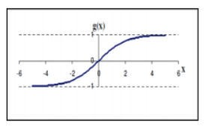
Figure: Bipolar sigmoidal function

Scales the input to a range between -1 and 1. Commonly used in hidden layers.

Pros: Smooth gradient, output values bound between -1 and 1, zero-centered.
Cons: Can cause vanishing gradient problem.

ReLU Activation Function:

A linear rectifier function has the i/p – o/p characteristics shown in the figure
• The function is linear for activation above zero and equal to zero otherwise
• An artificial neuron unit that uses the rectifier function as its non-linearity is called a rectified linear unit (ReLU)
• Most machine learning practitioners use ReLU units for intermediate layers of a neural network
• Due to the simple mathematics, the ReLU unit, networks with ReLU units are easier to optimize than those using sigmoid activation.

ReLU(x)=max(0,x)
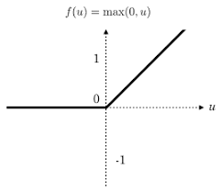

Outputs the input directly if it is positive; otherwise, it outputs zero. Widely used in hidden layers.

Pros: Computationally efficient, reduces likelihood of vanishing gradient problem.
Cons: Can cause "dying ReLU" problem where neurons output zero for all inputs.

Leaky ReLU Activation Function:

To mitigate the dying ReLU problem, Leaky ReLU introduces a small gradient for negative inputs, preserving some activity in the neurons.
However, it struggles with consistency for negative inputs, using a fixed slope throughout training.

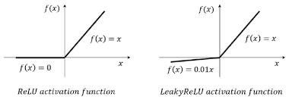

Pros: Mitigates "dying ReLU" problem.
Cons: Selection of the slope parameter α is crucial.

LAB TASKS
- Plot Activation Functions:
Write a Python program to plot the Linear, Sigmoid, Tanh, ReLU, and Leaky ReLU functions for inputs ranging from -10 to 10.

- Implement and Test:
Implement the activation functions in Python.
Test the functions with various inputs and compare the outputs.

LAB OUTCOMES

This lab helps students understand and visualize different activation functions used in neural networks. By implementing and experimenting with these functions, students will gain insights into their impact on neural network training and performance.

